Better GPT Node Version TSR

# Background

This test summary report is to verify what version of node(and npm) is required to run bettergpt.

I started doing this because I tried apt installing node on ubuntu and it gave me like version **12.22** or smth.

And it didn’t start up… so I installed the latest version, and it seemed to work.

So naturally, I wanted to know which version it stopped working on.

**Note**: this testing and document is only valid for the codebase at this point in time commit: <https://github.com/ztjhz/BetterChatGPT/commit/ecad41fd729cb36968aa4866391692d02a51af89>

Findings may not be valid after or before this commit as the codebase would have changed.

# Testing Method

I basically started from the latest version and used an approximate binary search pattern to pick and choose version to try running it on, and then trying to boot up the application.

I used nvm(Node Version Manager) to do this because it made it so easy.

## Validation steps

Once I decided on the version, the steps were simple:

1. Use nvm to install the version that was selected
   1. nvm list-remote to view all versions:  
      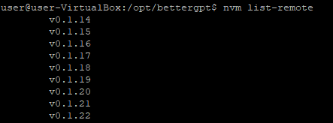
   2. nvm install to start using the version that you choose:  
      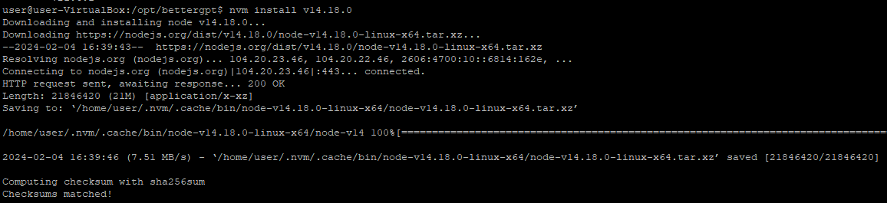
2. Pull a fresh bettergpt project
   1. git clone
3. Run npm install using the selected version
   1. As per <https://github.com/ztjhz/BetterChatGPT/blob/main/README.md?plain=1#L143>
4. Use npm run dev to validate that the version is running
   1. As per <https://github.com/ztjhz/BetterChatGPT/blob/main/README.md?plain=1#L144>
5. Validate the VITE output
   1. 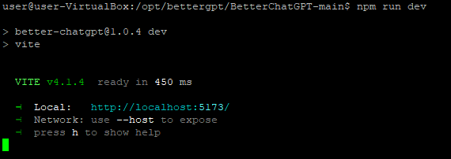

# Findings

Using the approximate binary search method, the following node version were tested:

* v13.14.0
* v14.0.0
* v14.15.0
* v14.17.6
* v14.18.0
* v14.18.3
* v14.19.3
* v14.21.3
* v16.20.2
* v18.19.0
* v20.11.0

And the results of testing are as below:

|  |  |
| --- | --- |
| Version | Launches BetterGPT? |
| v13.14.0 | No |
| v14.0.0 | No |
| v14.15.0 | No |
| v14.17.6 | No |
| v14.18.0 | Yes |
| v14.18.3 | Yes |
| v14.19.3 | Yes |
| v14.21.3 | Yes |
| v16.20.2 | Yes |
| v18.19.0 | Yes |
| v20.11.0 | Yes |

# Summary

Based off the above, BetterGPT will start up(using npm run dev) when using node version **v14.18.0**.

The version of NPM associated with that node version is **6.14.15.**

Thank you for coming to my ted talk.